- Consider the following two data streams users and orders is ingested into Kafka topics. Assuming KSQLDB is to be used for stream processing, answer the following questions. [2 + 1 + 2 + 3 + 2 = 10 Marks]

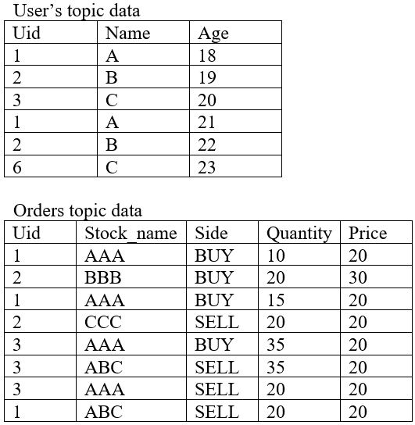

a) Represent both topics data as KSQLDB streams and tables. [2 Marks]
b) What is appropriate collection to be used respectively for Users data and Orders data? Why? [1 Marks]
c) If data from Orders collection is joined with Orders collection using left-outer join based on “Uid”, what will be the output of the resulting operation? [2 Marks]
d) If data from orders collection is grouped by stock name and side for measuring quantity counts and average price of stocks, what will be output of the resulting operation? [3 Marks]
e) You need to monitor the accounts of users who has placed overall orders having quantity greater than 50. Provide a KSQL query snippet along with expected output for the same. [2 Marks]

- Consider the following pseudo code for a streaming application monitoring the temperature of a steam boiler. At every regular interval say t units a reading is received from the boiler and further passed through the below code of a framework which encourages tuple-by-tuple processing of data. [3 + 1 + 1 + 1 + 3 + 1 = 10 Marks]

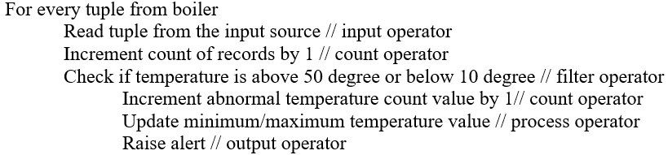

a) Draw a block diagram of a pipeline which will show the flow of data through this framework. [3 Marks]
b) At least how many nodes will be required for the cluster setup to process this code? [1 Marks]
c) How scalability and fault-tolerance be handled for such cluster setup? [1 Marks]
d) What is advantage of such processing against the one adapted by Spark Streaming? [1 Marks]
e) For following sequence of temperature values showcase the output of processing . [3 Marks]
35, 30, 9, 35, 30, 54, 35, 30, 7, 35
f) If Spark streaming needs to use for this data processing, what is minimum and maximum number of nodes will be required for the processing? [1 Marks]

- Assume that you need to count how many times an article is read – article is represented with a number like article 1 as 1, article 2 as 2 and so on. Employ a 4-row Count-Min Sketch for this exercise. The hash functions are as follows
Hash1 = (input * 2 + 1) mod 3
Hash2 = (input * 2 - 1) mod 3
Hash3 = (input * 3 + 1) mod 6
Hash4 = (input * 3 - 1) mod 6
Hash5 = (input * 2 + 2) mod 6
The articles are read in sequence 1, 3, 3, 8, 1, 3, 8, 5.
a) For each of the input show the state of Count-Min sketch with all relevant computations. [8 Marks]
b) Per the Count-Min sketch how many times the article 5 is read? What can be done to improvise the correctness of Count-Min sketch? [2 Marks]

- Consider the following version of the algorithm to maintain top-k products. If following is the sequence in which the products are sold, what are the top-5 products at the end of this sequence? Show all the intermediate execution steps of the following algorithm that helped you to arrive at the list. [6 Marks]

P1, P2,P3,P3,P3,P1,P4,P1,P4,P1,P5,P7,P7,P6,P9,P6,P10,P9,P1,P12,P3,P4,P2

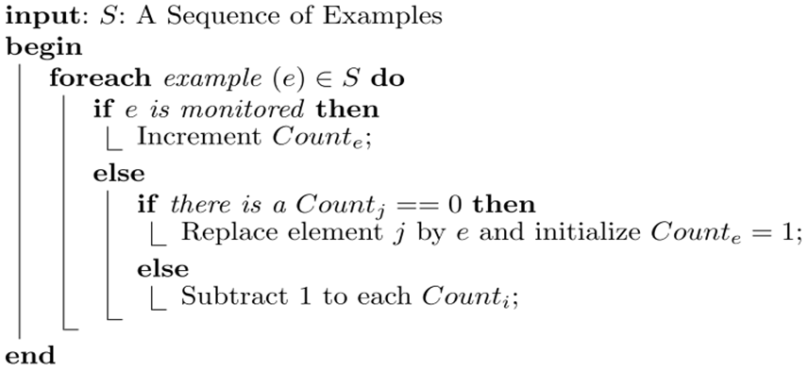

- The filter is used for fraud detection problem. A Bloom filter has an estimated capacity of 256MB. The filter could store 512x10 ⁸ events using 8, 16 and 32 hash functions respectively.
a) In each of these three cases, compute the % of events that are likely to be predicted as fraudulent transactions though they are actually not. [1+1+1=3 Marks]
b) What will be the optimal number of hash functions in this case? [1 Marks]

